**Appendix 5 – Efficient Analysis of the ImageJ Histogram Data using Excel**

Open up the saved histogram file from ImageJ using Excel. You will have to import it… select **Yes** and **Next** when prompted. The file that will open up will have two columns: **Value** (the ImageJ color code) and **Count** (the number of pixels of that color value). First, sort the data via the column Count, from largest to smallest (there are a total of 255 values). You can ignore the many rows that have values with zero counts. Then, for the values that have non-zero count data, calculate the sum of all counts, the sum of the counts of the four land cover classes that correspond to forest (values 61, 127, 179, 215; see Table 1). Next, calculate the proportional coverage of forest (= forest counts / total counts).

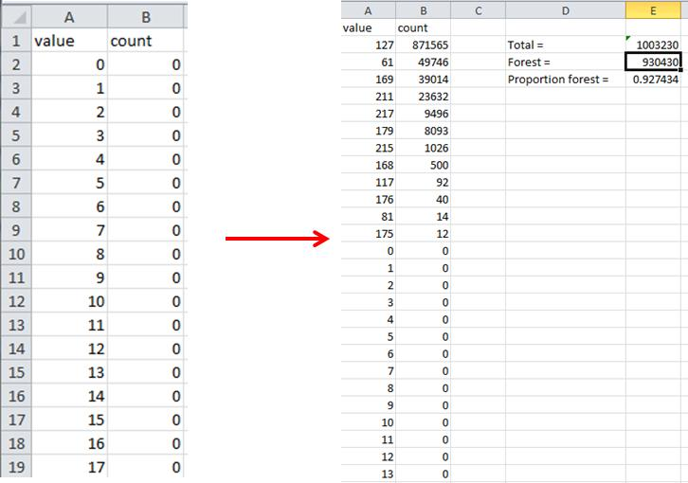

***Fig. 1 ImageJ histogram data before and after data processing in Excel.***



***Table 1. Key for translating ImageJ Color codes to the 2001 and 2006 NLCD land use / land cover classes.***